NC Division of Vocational Rehabilitation Services | 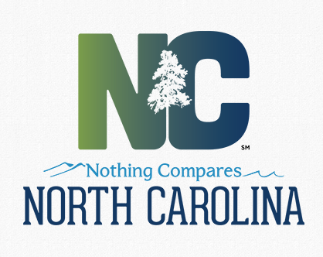 | NC Division of  Services for the Blind

CERTIFICATE OF COMPLETION
This certificate is presented to (full name)

For successfully completing the following training

CAREER COUNSELING

DATE OF TRAINING:

LOCATION OF TRAINING:

TRAINING PROVIDED BY:

ORGANIZATION:

SIGNATURE:

dsb-4008sub-VR-C A copy is to be retained by Agency Client ID:
New 9/2016 Date Certificate Provided to Recipient:
Method: Initial:

